**Batch:14**

**Name:saketh**

**Roll number:2403A51337**

**Task Description#1**

* **Zero-shot:** Prompt AI with only the instruction — Write a Python function to generate the Fibonacci sequence up to n terms

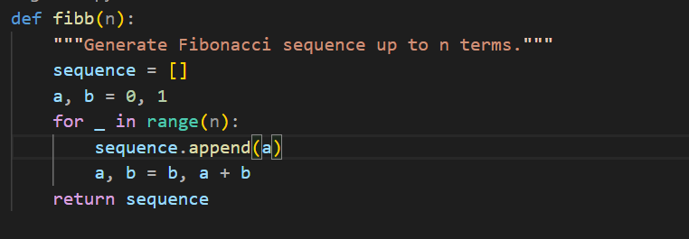

**Task Description#2**

* One-shot: Provide one example: Input: 100, Output: 37.78 to help AI generate a function that converts Fahrenheit to Celsius.

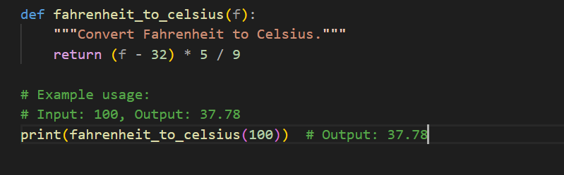

**Task Description#3**

* **Few-shot:** Give 2–3 examples to create a function that extracts the domain name from an email address.

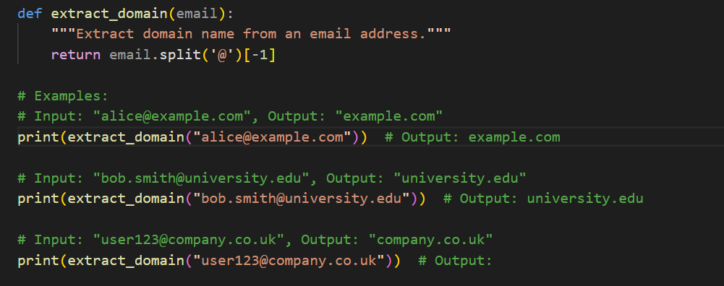

**Task Description#4**

* Compare zero-shot vs few-shot prompting for generating a function that checks whether a word is a palindrome, ignoring punctuation and case.

ZERO_SHOT :

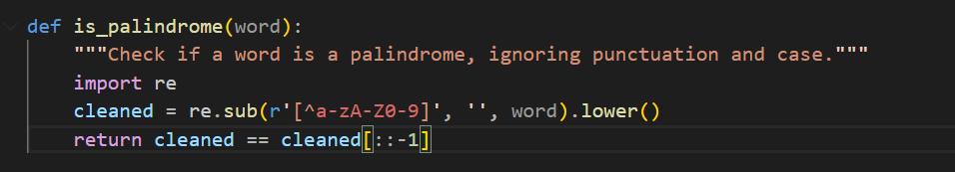

**Few_shot:**

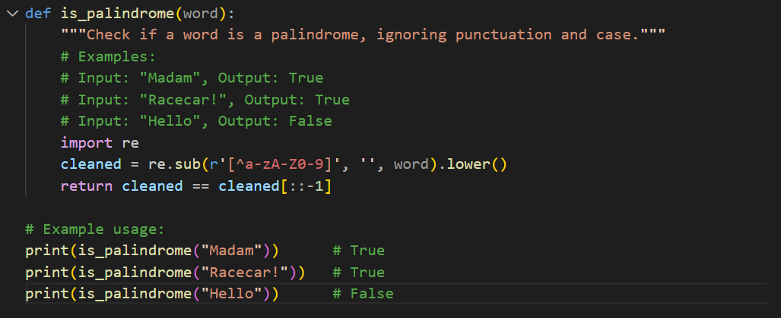

**Task Description#5**

* **Use few-shot prompting with 3 sample inputs to generate a function that determines the maximum of three numbers without using the built-in max() function.**

